Software Requirements Specification Template

Children Monitoring System iOS

Software Requirements Specification

version 1.3

12/03/2017

Alekhya Devi Manne
Karthik Laddipeerla
Koushik Lakkaraju
Prathibha Kamani
Reshma Shaik
Unnathi VallapuReddy
Veera Kishon Kumar Mucherla

Submitted in partial fulfilment
Of the requirements of
CSIS 44-691 Graduate Directed Project 1

Revision History

Date | Description | Author | Comments
09/22/2017 | version 1.0 | Karthik Laddipeerla | Created Requirement Document
09/29/2017 | version 1.1 | Prathibha Kamani | GUI, Use cases and ER designs added
11/07/2017 | version 1.2 | Prathibha Kamani | User manual added
12/03/2017 | version 1.3 | Prathibha Kamani | System Manual

Document Approval

The following Software Requirements Specification has been accepted and approved by the following:
Signature | Printed Name | Title | Date
Unnathi | Unnathi VallapuReddy | Business Analyst | 09/22/2017
Prathibha | Prathibha Kamani | UI Design | 09/29/2017
Prathibha | Prathibha Kamani | Developer | 11/19/2017
Prathibha | Prathibha Kamani | Developer | 12/03/2017

Table of Contents

Table of Contents Page Number

- Introduction 1
  - Purpose 1
  - Scope 1
  - Definitions, Acronyms, and Abbreviations 1
  - References 1
  - Overview 1
- General Description 2
  - Product Perspective 2
  - Product Functions 2
  - User Characteristics 2
  - General Constraints 2
  - Assumptions and Dependencies 2
- Specific Requirements
  - External Interface Requirements
    - User Interfaces 2
    - Hardware Interfaces 3
    - Software Interfaces 3
    - Communications Interface 3
  - Functional Requirements 3
  - Use Cases 4
  - Class/Objects 6
  - Non-Functional Requirements
3.5.1. Performance 6
3.5.2. Reliability 6
    - Availability 6
    - Security 6
    - Portability 6
  - Inverse Requirements 6
  - Design Constraints 6
  - Logical Database Requirements 6
  - Other Requirements 7
  - Use Case Diagrams 7
- Design
4.1. ER diagram 8
4.2. GUI 8
- Analysis Models
5.1. Data Flow Diagram 13
5.2. Sequence Diagram 14
6 .User Manual
6.1. Download Mobile App 15
6.2. Register to your Mobile App 15
6.3. Login to your Mobile App 16
6.4. Navigation to your Phone 17
7. System Manual
7.1. User administration and support 20
7.2. Security administration 20
7.3. Data administration 21
7.4. System Management 21

Introduction
The main idea of this document is to provide the basic understanding of the scope, abbreviations and lot of other details of the project to all its corresponding stakeholders.

  - Purpose
This document gives an elaborated description about the requirements for the project – “Child Monitoring -IOS”. In addition, it also lists out all the constraints for the project. This document is aimed primarily at the client and the project team awaits approval for the development of the first version of the system in proposal.

  - Scope:
The software “Child Monitoring System - IOS” is a monitoring system specially designed to control and protect the under aged from entering the 18+ locations and dangerous locations. The location history is generated and stored in the application and the parents will review them by the parent credentials, which will be different from the child credentials.
The software needs the GPS and internet to be switched on so that it can track the location and real time as the child moves from one place to another.

  - Definitions, Acronyms, and Abbreviations
Swift: Programming language for developing iOS applications.
Xcode: Developer tool for creating an iOS application.
Model: A schematic description of a system that accounts for its known or inferred properties [http://www.answers.com]
CMS: Children Monitoring System
GPS: Global Position System
SYSTEM: Any interactions performed by the application are considered to be performed by the Admin.
Version: A particular form of something differing in certain respects from an earlier form or other forms of the same type of thing.
ER: Entity Relationship

  - References

- http://www.hongkiat.com/blog/parental-control-apps-android/
- https://www.tomsguide.com/us/best-parental-control-apps,review-2258.html
- http://www.parents.com/parenting/technology/best-apps-for-paranoid-parents/
- https://www.familyeducation.com/fun/mobile-apps/10-apps-parents-monitor-kids-mobile-use
- http://www.uml-diagrams.org/use-case-diagrams.html

  - Overview
Overall the application that is in proposal for development is going to be robust and versatile and this application is only made for the Apple gadgets i.e., iPhone, iPad.

- General Description
This section will provide the overview of the functionality that is going to be witnessed in the application and it will help get everyone understand the basic mechanism of the application.

  - Product Perspective
Child monitoring system iOS application consist of two parts: one parent and one child. The parents use this application in order to track their children. The location history is saved and can be reviewed by the parent. To use this application, internet should be there.

  - Product Functions
The application majorly runs backend by frequently capturing location data with the help of the global positioning system in the gadget. Here, there are three main functionalities, which are login functionality, enabling the tracking option and storing the location.

  - User Characteristics
There are two categories of users for this application, one being the parent and another being the child. The common identification number, which helps us differentiate between the two categories, interlinks both the parent and child and this link would help us keep the information safe in the database.
Firstly, the parent user registers with all the required credentials and generates a registration id, which is going to be a reference id for the child user to register linking both the users. The credentials of both parent and child are going to be important will be well protected in the database and this particular design is greatly efficient preventing redundant data, helps the application load faster, and work better.

  - General Constraints
The iOS applications is constrained by the system interface to the GPS navigation system within the mobile phone. Since there are multiple system and multiple GPS manufactures, the interface will most likely not be the same for every one of them. In addition, there may be a difference between the navigation features that each of them provide. The internet connection is also a constraint for the application. Since, the parent should have internet to monitor their children.

  - Assumptions and Dependencies
One assumption is that the GPS components in all phones work in the same way. If the phones have different interfaces to the GPS, the application need to be specifically adjusted to each interface and that would mean the integration with the GPS would have different requirements than what is stated in this specification.

- Specific Requirements

  - External Interface Requirements

    - User Interfaces
The user interface is going to be very simple and friendly. The first page is the register page, which asks the user to identify himself or herself as the parent or the child, which will take us to the second view where the actual registration begins. The third and final view is the functional view of the application, which does not require any input for action from the user. The application is going to function by itself from here.

    - Hardware Interfaces
There is not much of a hardware interface requirement as the GPS comes in-built on the gadgets that the application is targeted.

    - Software Interfaces
The software that we have adopted to complete this project, should be compatible for the smooth running of the application. Application should not crash in any scenario and use new versions of API for flexibility.

    - Communications Interface
Team must work collaboratively for the productive work. Sharing ideas and brainstorming in the project team meeting would help us complete the project within the given deadlines. Effective client meeting will help the team to gather requirements accurately in a timely manner.

  - Functional Requirements
- Should download the application from the app store.
- Login screens allows the user to access, home page allows parent to choose child and then navigate to location tracking page (which display child current location). Forgot screen allows the user to reset their password, signup page allows to user to register to get access.
- User should enter the Username, which contains alphabets, numbers in login page.
- User should enter a password with a combination of alphabets, numbers and special characters in login page.
- Login Screen should have username, password text fields, login button, create an account for new user, forgot password filed.
- Signup page should have first name, last name, email Id, user name, password, address, phone number.
- Forgot Page should have a text field asking for email address and submit button, so that user get a link for reset password.
- Application home page for parent should have one or more buttons for the child and another extra button for adding new child if desired.
- Application home page for children will have their location on the screen wit name of location, latitude and longitude text fields on the screen.
- Application navigation page (location tracking page) for parent should contain image of child field, current location of child, activities of day, history of location.
- Children and Parent should enter the data into the system.
- All the location of particular child is stored, saving the reports generated for future retrieval.
(m) Should check for updates automatically with an edit option.

  - Use cases

Name: | Start Application
Actor: | Parent/Child
Entry  Conditions: | Application is currently in progress
Flow of  Events: | 1. Parent/Child registration  2. SYSTEM confirms that the user wishes to register.  3. SYSTEM saves the records.  4. User submits the form
Exit  Conditions: | Application is now in a new state.

Name: | Parent/Child Login
Actor: | Parent/Child
Entry  Conditions: | Application is currently in progress
Flow of  Events: | 1. Parent/Child login to the App.  2. SYSTEM checks with databases and if the username and password match is found, and then the application redirects the user to the main menu.s
Exit  Conditions: | Application is now available to the user.

Name: | Parent/Child forgot password
Actor: | SYSTEM & Parent/Child
Entry  Conditions: | System verify email id entered by the user.
Flow of  Events: | 1. If the email is present in the database then the request is triggered to the SYSTEM.  2. SYSTEM sends the link to the respective user to reset password.
Exit Conditions: | Now user has an access to enter into an application.

Name: | Parent/Child application settings
Actor: | SYSTEM & Parent/Child
Entry  Conditions: | User can change settings according to their requirements
Flow of  Events: | - User can enable the location tracking option.  - SYSTEM saves the newly saved settings.
Exit  Conditions: | Now the Parent has an access to check the child location.

Name: | Parent/Child tracking details
Actor: | SYSTEM & Parent/Child
Entry  Conditions: | Parent requests for child location.
Flow of  Events: | - SYSTEM sends the location of the child to the parent.  - SYSTEM stores records each instance of child location in the database.
Exit  Conditions: | Parent tracks the location of the child

Name: | Parent/Child records
Actor: | SYSTEM & Parent/Child
Entry  Conditions: | User chooses an option of receiving notifications from the SYSTEM about the location tracking records.
Flow of  Events: | SYSTEM saves the location records of the child and sends it to the parent based on their time span they have opted for.
Exit  Conditions: | User will get the notifications regarding the location records of their child.

  - Classes/Objects
Parents and children are key entities in the project.

  - Non-Functional Requirements

    - Performance - The application would be self-explanatory i.e., it can be easily understood and accessed by both adults and children. Parents get the accurate location of the children with the proper GPS functionality used. It works with any version of iOS installed in the mobiles, but the performance would be much better with the latest version installed.

    - Reliability - The components of the project shall be tested in parallel to the implementation in order to ensure that they are functional. The entire project code and the functioning shall be tested with Swift through manual testing to ensure the highest chance of being the quality code.

    - Availability - The Children Monitoring application shall be used to track the location at any place, without restricting the distance and area. Unless the system is non-operational, the application shall notify the parents every time their children leave them.

    - Security - One needs to register for the first time in order to use this application. The user shall be asked to answer some security questions at the start so that they would be helpful at the time of forgetting the password. Not everyone can track the children unless they have their own credentials to login.

    - Portability - The application works for the current version of iOS, but it might not work for the previous versions, as the same functionalities may not be available for them. However, it can work for higher versions of iOS, with parallel updation of the application.

  - Inverse Requirements
User Interface of the app should not be rigid and complicated for use by parent. App should not trace the child’s course all the time and should do that only when the parent wants to do so. App should not be vulnerable to attackers and it should maintain the confidentiality of the child’s trace route.

  - Design Constraints
Size of the app is the major design constraint that we are facing. There are certain limitations in terms of screen sizes that our app could run.

  - Logical Database Requirements
Database should have enough storage space for the app to store all the child and parent details and their trace routes. Database should be quick and effective in retrieval of child past records.

  - Other Requirements
App should have provision for the user to sign up through their social media account. App should contain an option to report to the police if the parent finds anything suspicious in their child’s trace route. App should be able to report to the user if any form of malicious software like virus or worms infects it.

  - Use Case diagrams

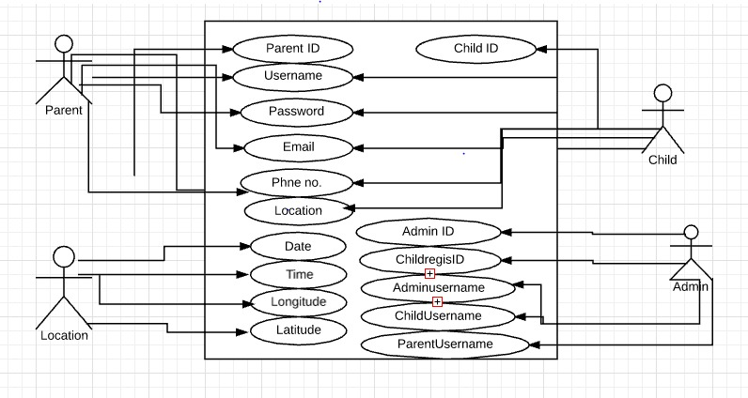
Fig: Use case Diagram

- Design

  - ER Diagram
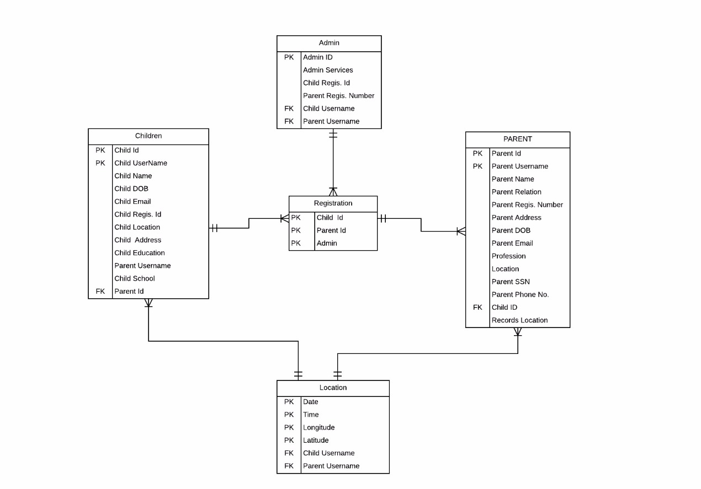
Fig.ER Diagram

  - GUI
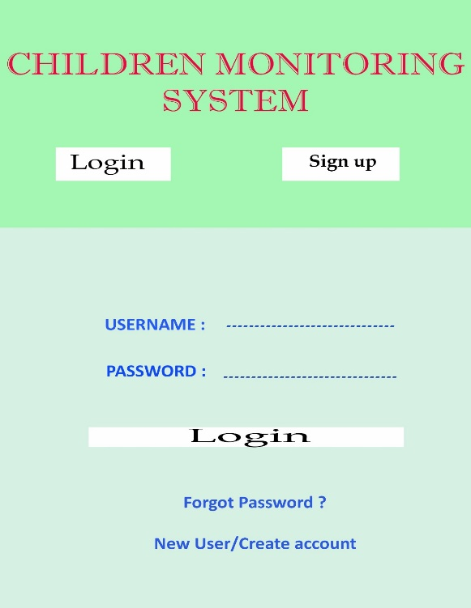
Application Register for New User:
This Application allows the new user to register, so that the new user will get the access to use this application. For registering purpose, app needs first name, last name, email Id, user name, password, address, phone number.

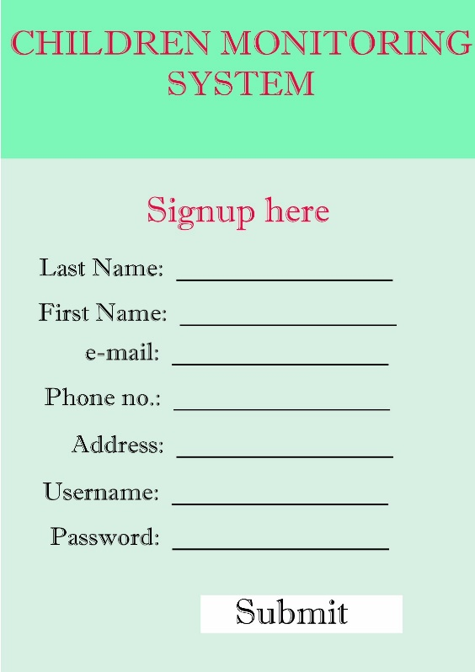

Application Login for the Registered User:
This Application allows the registered user to get into the application once their username and password check is done successfully, the check of username and password is done based on the data stored in the database of the application. In this we have username, password edit-text and login button along with forgot password option.

Application Forgot Password option:
This Application allows the user to get their password if they forgot it by checking the registered email address of the user in the database. System automatically sends a verification code to the user’s registered email address, so that application ensures that only authorized users have access. In this we have a one edit-text for entering email address, and submit button so that a link will be send to your email for resetting password.

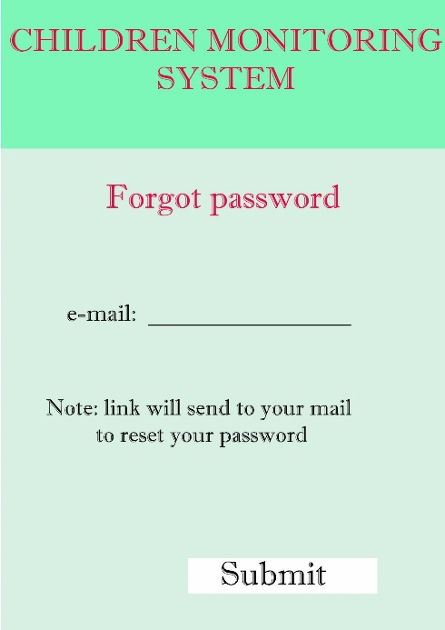

Application Home page:

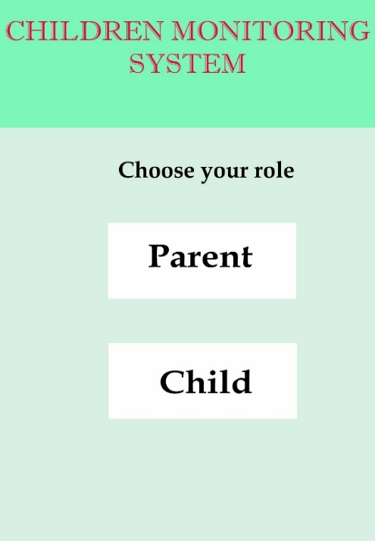

Home page of this application have option for parent to select a child for whom they want to track the location and the parent have an option to add a new child. For Child, he/she will have an image and all the current details of his location.

Child front end:

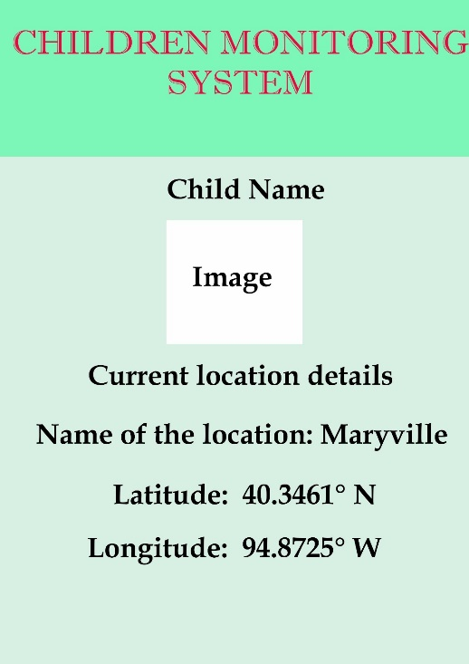

Parent front end:

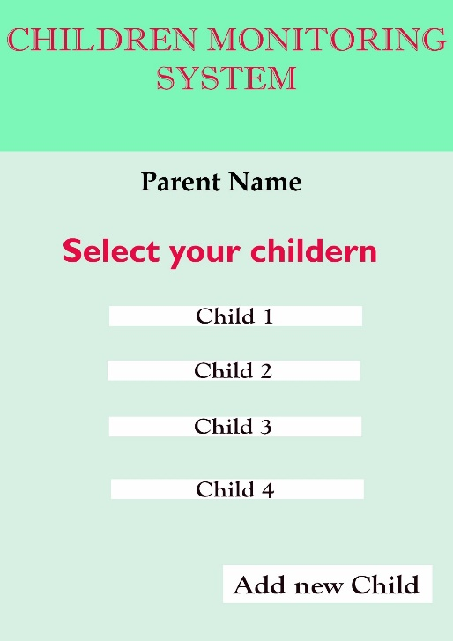

Application Navigation Pages:

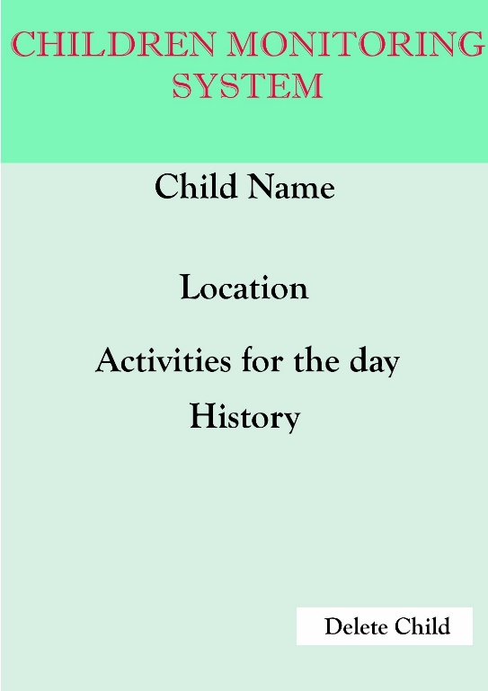

If parent selects particular child then the parent will get all the details of that selected child i.e., current location of child, Activities done for that day, History of child location, Delete the child.
- Analysis Models

  - Data Flow Diagram

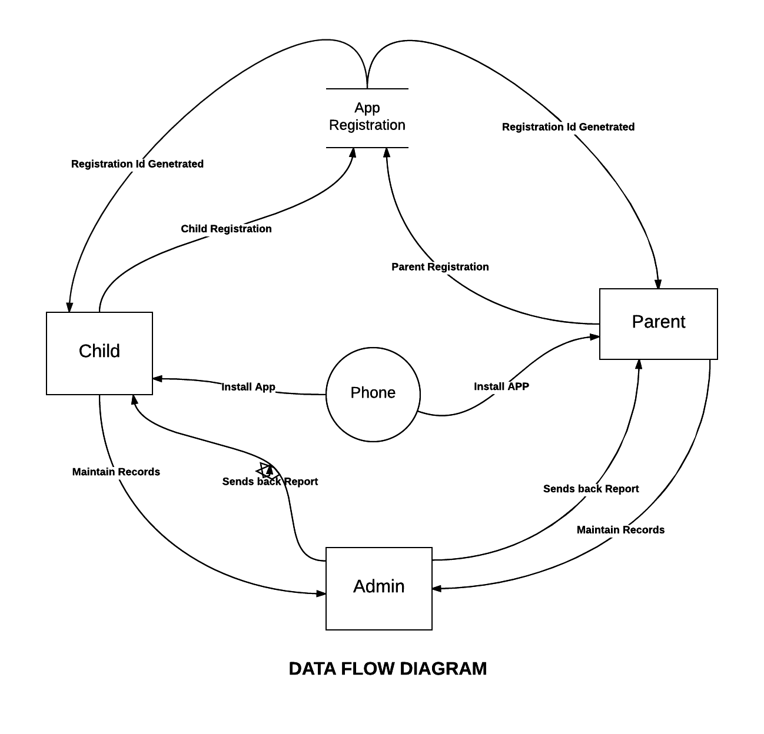

Fig. Data Flow Diagram

  - Sequence Diagram

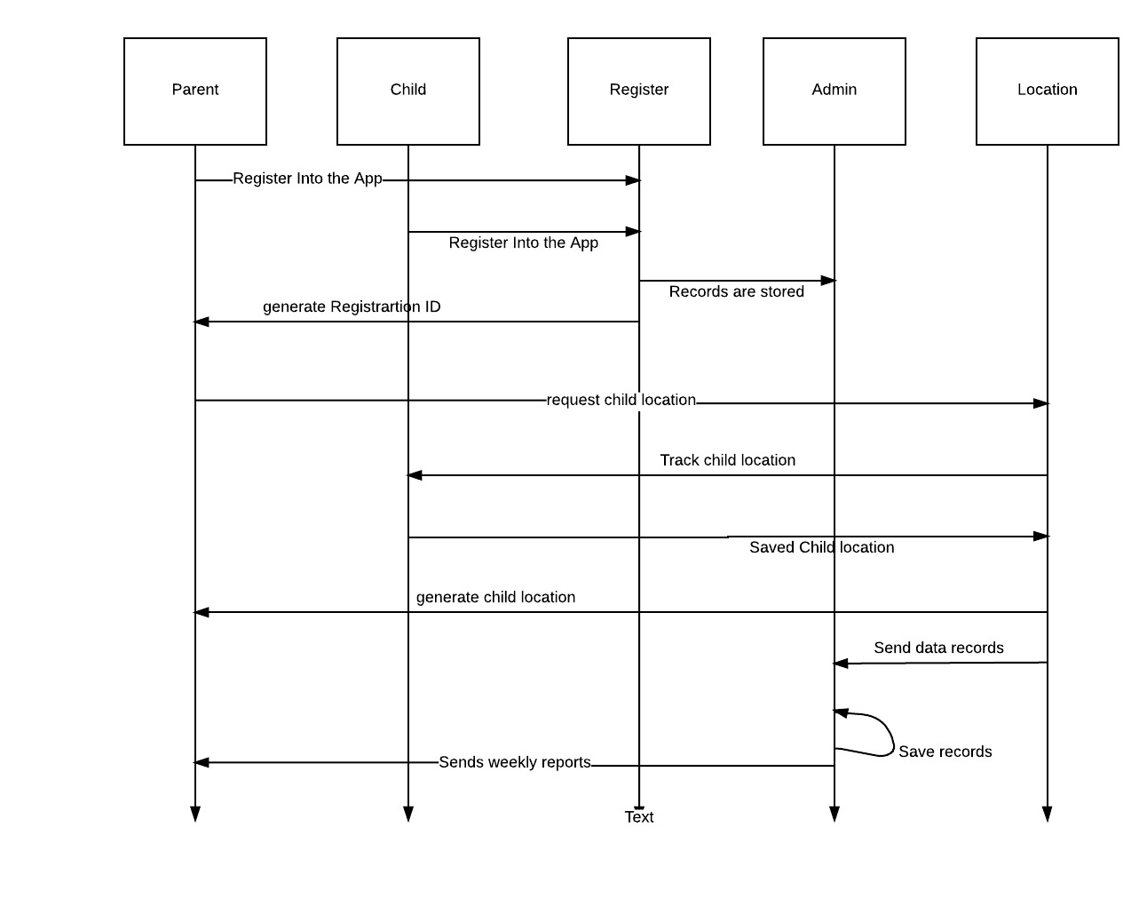

Fig. Sequence Diagram

- User Manual

  - Download Application:
Children monitoring system application will be available in the apple store.
- Go to Apple store in your mobile.
- Search for children monitoring system application.
- Select the application.
- Click on install.

  - Register to your Mobile App:
As you are the new user for this application you need to register to the application by provide your information, so that your information will be saved in the database. By storing your information in the database you can directly login into your application by providing your username and password.
- Tap on the children monitoring system app icon on your phone.
- Enter the name, email, password, confirm password, select security question, and answer for security question.
- Press signup.
- All your details will be stored in database.
- If you do not desire to register then you can press on cancel on the top left.

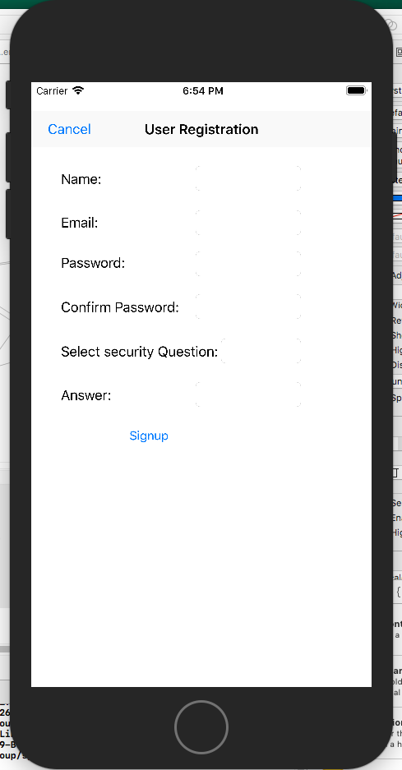
Fig. Registered Page

  - Login to your Mobile App:
As your details are registered in application database. You can directly login into your application by providing your details.
- Tap on the children monitoring system app icon on your phone.
- Using the same information when you registered, type your “User Name is your email” and “Password”.
- Select Login.

Note: If you forgot your password, then press on forgot password in the login page. Password will be sent to your registered email.
- Enter registered email address and select security question.

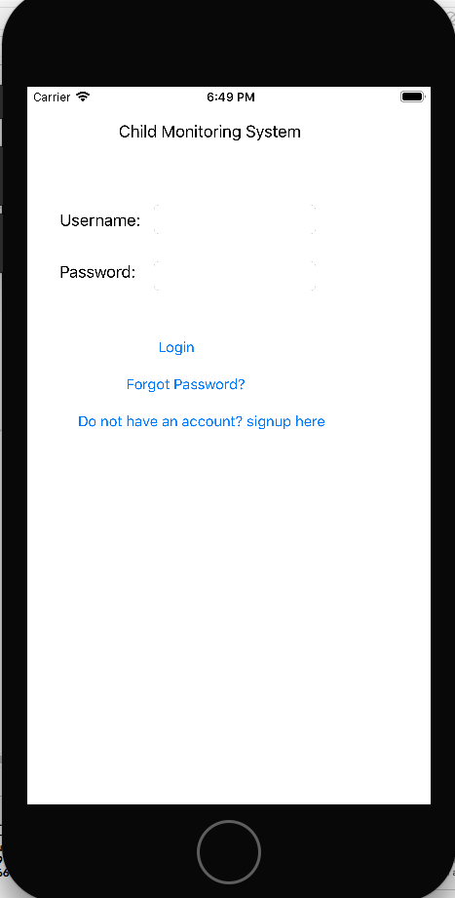

Fig. Login Page

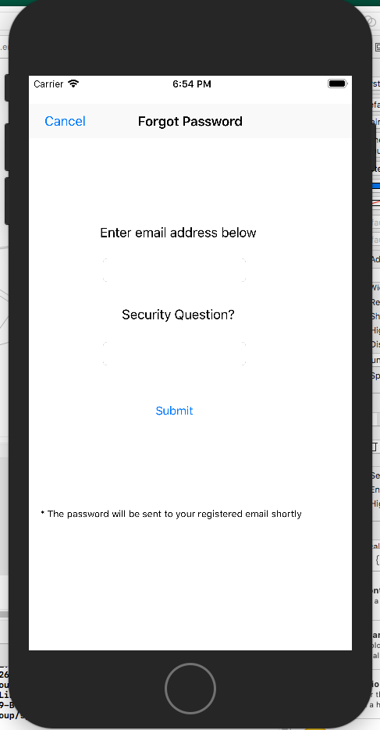

Fig. Forgot Password Page

  - Navigating your phone:
When you login into the application, then you will be directed home page.
- Tap on add new child button, which will be redirected to add child page.
- In the add child page, Enter details like child name, select days of the week, select timings and select frame.
- Tap on the add child button, child will be added in the home page. To redirect to home page just press back button in the navigation bar.
- To edit the details of the existing child press on set button and follow the same steps above.
- In the home page, to view the details of child press on the respective child, it will be redirected to the tracking page of the child.
- In this tracking page, you can see map where the child is present and the summary of the location.
- Tap on the edit tracking setting button to edit the settings of the location.
- To go back to the home page press on the home button present on the right corner.
- To sign-out from the home page press on the sign-out button present on the below left corner.

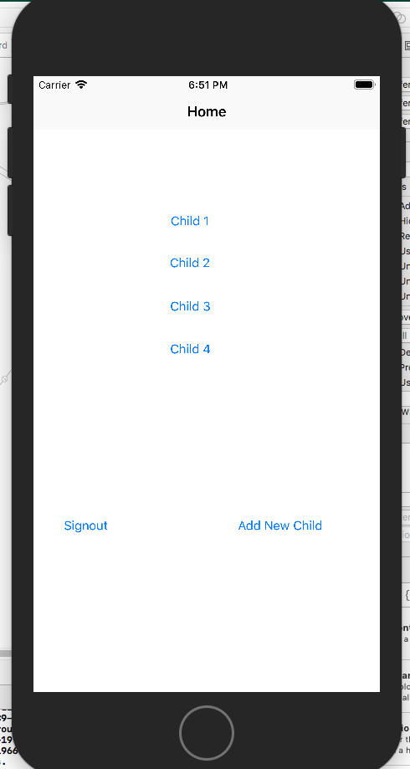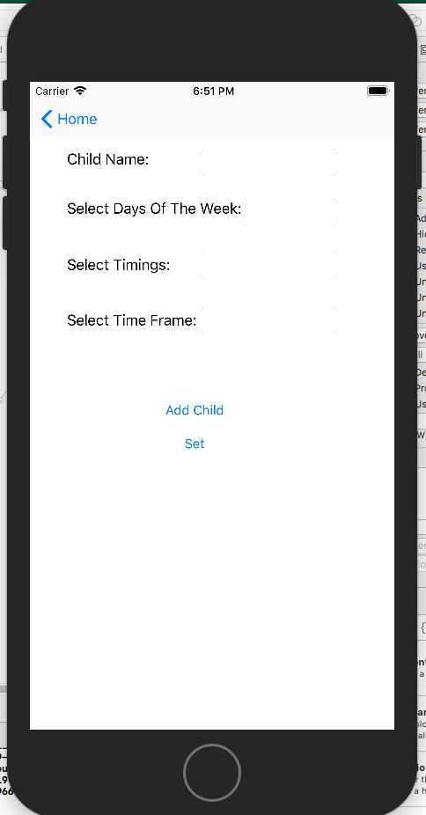

Fig. Home page Fig. Add child page
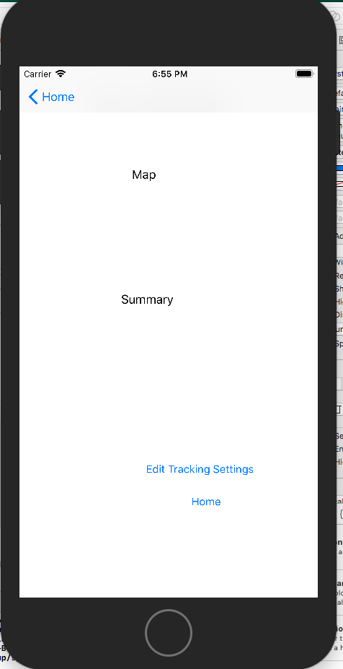

Fig. Tracking Child page

- System Manual

  - User administration and support:
As the user register into the application the data (Name, Email Id, Password, Security Question, and Answer) will be stored in the backendless database system (online database storing system). Once the data is stored in the database the user will be able to login to the application using the email as username and password given by the user.

If the user forgets the password, then the user can request for forgot password.
- When the user enters the Email Id, then the Email Id will be searched in the database records, then if the match was found the newly generated password by backendless will be sent to the respective mail address, which will be make the effort of user easy.

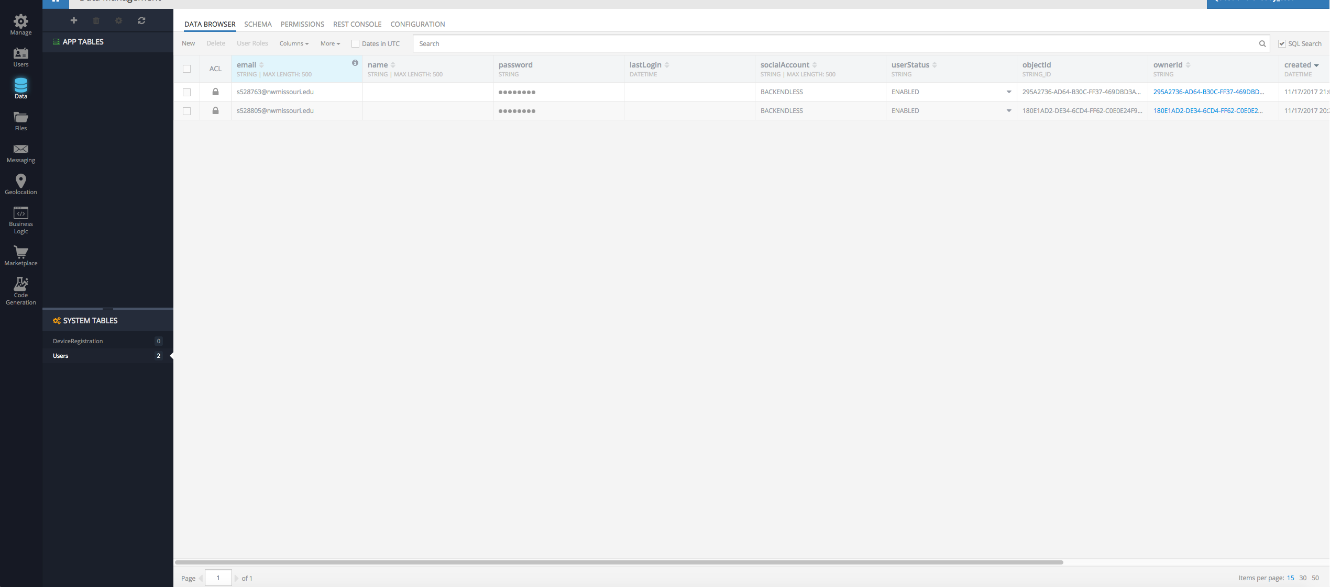

  - Security administration
For any application security plays a vital role, so we need to concentrate on the security of individual user data from being data breach. As this is a simple application which is not being related to the finance we have not implemented much security to the application, but we have given an option for security question which will be helpful in valid user enters into application and will be able to use his/her data alone.

Security question and answer will be provided by the user at the time of registration.
- The security question will be stored in the database.
- When the user enters the answer for the security question then the application will invoke the database for the basic check of the security question and answer.
- When both the security question and answer matches for respective user then only the user will be allowed to the application.

  - Data administration
For any application data management and administration is so important.
- The system is designed in such way that all the data entered by the user will be stored in the database.
- The system is designed in a way that each specific user is given a specific storage space allocation which will eliminate the storage issues for the user.
- The data backup should be made on a timely basis, so that will not lose the data and helpful for future usage.
- The system should maintain data integrity, so that the data will be consistent through all the application.

  - System Management
Our system is all about the parents use this application in order to track their children. The location history is saved and can be reviewed by the parent. To use this application, internet should be there.
- Every parent (user) will set up the settings as per their requirement, based on which the data will be stored in the database.
- Reports of the child location will be stored in the database and the parent can pull the records/view it at any time for any specific time.
- All the location details of the child will be stored in a separate table
- The parent is allowed to delete the location of the child in their settings tab, this is used to save the memory of the application.

